Worshipping Together
West Sussex Coast and Downs Circuit
February 2020

Worshipping Together is an offering from the circuit to you, and has been collated by local preachers, ministers and worship leaders from across the circuit.

If you are well enough, we invite you use this resource each week, at a time to suit you, and spend a few moments with God, knowing that you are Worshipping Together with other people who are also sharing in this act of worship with you.

Share these resources with others to use in their own way as we worship and grow together despite the pandemic.

Also available at: www.westsussexcoastanddownscircuit.co.uk

And may the Lord make you increase and abound in love for one another and for all, just as we abound in love for you.

1 Thessalonians 3:12

Sunday 7th February 2021

GATHERING
As we come to worship, you may like to prepare with a period of quiet, or light a candle. Let us remember that wherever we are, God is with us.

Have you not heard? The Lord is the everlasting God, the Creator of the ends of the earth…those who hope in the Lord will renew their strength. They will soar on wings like eagles, they will run and not grow weary; they will walk and not be faint.’ Isaiah 40:31

Prayers of Thanks and Praise
Creator God we worship you and praise you for all you have done in our lives.
You have made us and our world, so full of beauty and adventure.
Even now, when we can no longer travel to enjoy that world in full,
we can pause and see the garden birds from our windows.
We may have gardens to enjoy and places to walk.
We have warm homes and food. So many others across the world are not so lucky and we give thanks for all those who try to help them in many different ways.

In the quiet times of lockdown we can stop and look and see what gifts you have given to us and thank and praise you. The greatest gift of all is your love shown to us through Jesus and kept with us through your Holy Spirit.
Unworthy as we are, we accept that love given so freely and we pray that we can spread the good news of that love to all around us. May you accept our worship and prayers today, Creator God, in the name of Jesus. Amen

Sing, Pray or Reflect: I watch the Sunrise YouTube: https://youtu.be/byEU7ZglRBY
I watch the sunrise lighting the sky, casting its shadow near.
And on this morning, bright though it be, I feel those shadows near me.
But you are always close to me following all my ways.
May I always be close to you, following all your ways, Lord.

I watch the sunlight shine through the clouds, warming the earth below.
And at the mid-day life seems to say: I feel your brightness near me.
For you are always close to me……..

I watch the sunset fading away, lighting the clouds with sleep.
And as the evening closes its eyes I feel your presence near me.
For you are always close to me….
I watch the moonlight guarding the night, waiting till morning comes.
The air is silent, earth is at rest – only your peace is near me.
For you are always close to me……

RECEIVING

Reading: Mark 1:29-39

Poor Jesus. He had asserted his authority over a demon in the synagogue at Capernaum and now he was overwhelmed with people who wanted to be healed in some way. The whole town was gathered outside his door. He had already healed Simon Peter’s mother-in-law. Now he set about healing some of the others. Can you imagine the scene? It must have been chaos. It must have been a bit like the chaos caused by the paparazzi that a celebrity of today has to face when they come out from behind the protection of their estate walls: cameras flashing, people yelling, all wanting to take something away with them about the celebrity that will sell to a newspaper. In the same way in Capernaum, everyone wanted a piece of their new hero!

It’s not surprising that come morning he runs away for some peace and quiet. He wanted to be alone with God, to spend time praying and preparing himself for the ordeal that he knew lay ahead of him and he was thrust into action instead. He told people not to spread the news of his healing. He told the demons not to tell anyone who he was. Why? Probably because he just didn’t feel ready. He wanted to stay quiet and pray, just to BE and he had to get up and DO. In the end he decided that what he was meant to do was to travel on and spread the word among other villages as well, not to stay and heal the people in just one place.

Sometimes it’s so much easier for us to find a nice place and get comfortable there and forget all about the people in other places that need our help. I shall never forget the first time an old lady said to me ‘I don’t know why people go on about helping Africans. There are plenty of people right here who need our help.’ I had to go away and think about that, because in many ways she was right. But when I asked myself what Jesus would have done, I came back to this small section of Mark 1 and I knew the answer. ‘Let us go somewhere else, so that I can preach there also. That is why I have come.’ The people of Capernaum now knew about God’s love for them. They now knew about the new teacher, Jesus of Nazareth, who spoke with such authority. Other people didn’t know yet. It was and still is the responsibility of all who know to spread the word to those who don’t know. We can never afford to just sit back and feel comfortable because WE know.

Just as Jesus travelled throughout Galilee, we need to keep on moving around, telling everyone who will come to listen. That’s at the heart of why we have local preachers. But I do wonder why there are so few of us? Why do more people not come forward for training? In all denominations there is now an acute shortage of preachers and ministers, especially among the younger age groups. Yet I know that God must still be calling people to come and travel in his name. Are people so much better at ignoring God’s call today? Would they all rather BE than DO? Or at the most DO within their own safe well-known environment. Or are they like my elderly friend? Do they think why bother with other places when there’s still so much to do here? Whatever the answer, the question needs to be asked, because nearly all our local preachers are getting old and the circuit currently has so few people in training. It worries me that so many of us are over 70 now and growing inevitably more forgetful and confused, no matter how good we used to be!

Of course it’s also possible to be so busy Doing that we don’t stop to BE. Sometimes we’re so busy rushing around, seemingly doing God’s work, that we forget to find the time to just sit quietly and BE in the presence of God. Finding the balance is difficult, but at this time of lockdown perhaps we have an opportunity to spend more time just BEING and finally stopping to listen to what God is trying to say to us all. Maybe we’ll even finally have some new preachers in training as a direct result. That would be a lovely silver lining to a bad situation.

RESPONDING

Reflect: How is God be calling you to DO and BE today?

Sing, Pray or Reflect: Will you come and follow me?
Will you come and follow me if I but call your name?
Will you go where you don’t know and never be the same?
Will you let my love be shown, will you let my name be known,
Will you let my life be grown in you and you in me?

Will you leave yourself behind if I but call your name?
Will you care for cruel and kind and never be the same?
Will you risk the hostile stare, should your life attract or scare?
Will you let me answer prayer in you and you in me?

Will you let the blinded see if I but call your name?
Will you set the prisoners free and never be the same?
Will you kiss the leper clean, and do such as this unseen,
And admit to what I mean in you and you in me?

Will you love the ‘you’ you hide if I but call your name?
Will you quell the fear inside and never be the same?
Will you use the faith you’ve found to reshape the world around,
Through my sight and touch and sound in you and you in me?

Lord, your summons echoes true when you but call my name.
Let me turn and follow you and never be the same.
In your company I’ll go where your love and footsteps show.
Thus I’ll move and live and grow in you and you in me.

Prayers for others
Dear God, we bring to you all those who are alone and feeling lonely or distressed at this difficult time. May they know that you are always with them, even now. Let them feel your love and know that through Jesus there is always hope, even as so many die of this terrible disease.

We pray for all those families who have lost loved ones, for those who have not seen their loved ones for such a long time, for those who have lost contact with family and friends and for those who have to isolate from families because of their daily contact with the sick and dying. Give us all the patience to see this through to the end, the courage to play our parts without complaint and the certain knowledge that one day soon it will end, for us at least.

Be with those millions across your world who will still be lost and alone, fleeing from conflict or poverty, living in a strange land in appalling conditions, hungry and afraid. Let your message of love and hope reach them and be with those who risk all to help them. Help also politicians across the world as they seek to establish a new world order, repairing the damage done by the pandemic and by our abuse of your planet. Help them to talk peace and reconciliation with despotic regimes who abuse their own people and attempt to seize land belonging to others.

May your gospel be restored in those places which have tried to banish your name and be with those who put themselves in danger to teach others about Jesus and your love.
In silence we pray for those know to us who are in need of special prayers today….
We bring all our prayers together with the Lord’s Prayer: Our Father…

The Grace
May the grace of our Lord Jesus Christ, the love of God,
and the fellowship of the Holy Spirit, be with us all forever more. Amen

Sunday 14th February 2021 | Racial Justice Sunday

GATHERING
As we come to worship, you may like to prepare with a period of quiet, or light a candle. Let us remember that wherever we are, God is with us.

As we gather on this Racial Justice Sunday, we think of the struggle of many to be treated fairly, to be spared mistreatment and prejudice. We pray for a peaceful resolution of differences and injustice, in a world that is stronger united and weakened when it is divided.

We pray…
Dear Lord, help us to respond to the Gospel
by loving each other and by sheltering each other from the rain.
We ask for your guidance to help us
to stand up and speak out for others and to spread your message of love.
We give you our all as you did for us, let this be our Calling. Amen.

When the bonds of love are breaking, v1-2

1.When the bonds of love are breaking,
hands that linked withdraw and hide,
eyes that once had met in candour
now distrustful, turn aside,
God of healing, Reconcile!

2.When our tongues are silent, sullen,
closing doors through which love came,
or when words are fiery arrows
wounding others with their flame,
God of healing, Reconcile!

RECEIVING

Reading: Psalm 133:1-3
“¹How good and pleasant it is when God’s people live together in unity!
²It is like precious oil poured on the head, running down on the beard, running down on Aaron’s beard, down on the collar of his robe.
³It is as if the dew of Hermon were falling on Mount Zion.
For there the LORD bestows his blessing, even life for evermore.

Reflect: This theme of unity and togetherness was so stunningly illustrated in Amanda Gorman’s speech at the inauguration of the President of the United States, Joe Biden. In her poem ‘The hill we climb’ she speaks of America striving to forge a union with purpose, to compose a country committed to all cultures, colours, characters and conditions of humanity, ‘so that we lift our gazes not to what stands between us but what stands before us.’

We are seeing similar struggles, no less real, based on difference in the nations of the United Kingdom. We have witnessed the protests of Black Lives Matter; disputes about ethnic and racial equality, as well as the inflammatory issues of immigration. What does this mean for the Christian message; for the role we can play in promoting racial justice? Once again, we can take the example of our Lord who spoke out against unfairness, tore down barriers, and challenged the things that divided his people. Even one word can often make a difference!

RESPONDING

Questions for REFLECTION:
How could we come together to forge ‘a union with purpose’?
What do you need to do to demonstrate God’s love, shared out for all?
How could you recognise opportunities to speak out in support of others?

Pray
Lord, thank you that each one of us is unique,
yet we share a common bond with you.
We come together as one body,
yet we learn and experience things in different ways.
Guide us Lord, in our complex world
And bless us richly as we call upon your name. Amen
We bring all our prayers together with the Lord’s Prayer: Our Father…

When the bonds of love are breaking, v3-4

When the bridges that we travelled
have collapsed and left a void,
when the chasm seems to widen,
separating souls once joined,
God of healing, Reconcile!

God, in Christ you crossed the chasm,
when our hearts were far from you!
Grant us grace to reach to others,
broken bonds repair, renew!
God of healing, Reconcile!

Closing Prayer
Lord it is not up to us to sort the bad from the good,
the wheat from the weeds.
Rather, send us out to love everyone equally,
and to do everything we can to promote your Kingdom. Amen.

The Grace
May the grace of our Lord Jesus Christ, the love of God,
and the fellowship of the Holy Spirit, be with us all forever more. Amen

Sunday 21st February 2021

GATHERING
As we come to worship, you may like to prepare with a period of quiet, or light a candle. Let us remember that wherever we are, God is with us.

Come, now is the time to worship.
Come, now is the time to give your heart.
Come, just as you are to worship.
Come, just as you are before your God, come.

Sing, Pray or Reflect: Lead us, heavenly Father, lead us

1) Lead us, heavenly Father, lead us
o’er the world’s tempestuous sea;
guard us, guide us, keep us, feed us,
for we have no help but thee,
yet possessing every blessing
if our God our Father be.
2)Saviour, breathe forgiveness o’er us;
all our weakness thou dost know,
thou didst tread this earth before us,
thou didst feel its keenest woe;
tempted taunted yet undaunted,
through the desert thou didst go.

3) Spirit of our God, descending,
fill our hearts with heavenly joy,
love with every passion blending,
pleasure that can never cloy;
thus provided, pardoned, guided,
nothing can our peace destroy.

Prayers for the First Sunday in Lent
Gracious and merciful God, we come to worship you,
to praise and thank you, to seek your forgiveness and to ask for renewal.
Create in us a clean heart, O Lord; and put a right spirit within us.

We come in the name of Christ, remembering his lonely days in the wilderness,
his time wrestling with temptation, and the ministry that followed,
restoring and transforming so many lives.
Create in us a clean heart, O Lord, and put a right spirit within us.

Help us to learn from his example – to search our hearts as he did,
to consider our calling, to reflect on our faith, to resist temptation,
and to commit ourselves more wholly to you.
Create in us a clean heart, O Lord, and put a right spirit within us.

Help us recognise all Jesus has done for us through his life, death and resurrection;
and so may we come gladly to you, confessing our sins, acknowledging our faults, accepting our weaknesses and receiving your forgiveness.
Create in us a clean heart, O Lord, and put a right spirit within us.

Gracious and merciful God, speak to us today and in the days ahead,
so that we may know you and love you better.
Create in us a clean heart, O Lord, and put a right spirit within us,
through Jesus Christ our Lord. Amen

RECEIVING

Reading: Mark 2:1-12

This is a well-known account of one of Jesus’s healing miracles. Mark gives us a lot of information in just 12 verses and our imaginations can take off as there is so much going on and a real mix of characters.

First there is the crowd - Jesus is in Capernaum where he has made his home. He already has a reputation and the crowds have gathered – packed inside and spilling outside. They are keen not to miss anything – they want to hear what he is saying and see if he performs any miracles. Each person in that crowd is going to protect his or her space – no amount of pushing and shoving will move them. Some of the people in the crowd had their own agenda – they were the teachers of the law who were there to check up on what this Jesus was saying and doing. When Jesus says to the paralysed man ‘Your sins are forgiven’ they immediately react – ‘he’s blaspheming’. I wonder how they felt when Jesus then healed the man and the crowd were amazed and praised God.

Secondly there are the friends of the paralysed man. We don’t know anything about them and when we read the story we tend to focus on the man on the stretcher. He was very fortunate – his friends clearly cared about him and were determined that he would meet Jesus. When it was obvious that they were not going to be able to persuade anyone in the crowd to let them get near to Jesus they went up on the roof, made an opening and lowered the stretcher down. It is their faith that Jesus recognises and leads to him healing the paralysed man.

RESPONDING

Reflect
As you read the account today ask yourself the following:
- If I had been in the crowd how would I have behaved? Would I have been so keen not to miss anything that I would have stood my ground and left the friends to find another route to Jesus?
- When Jesus said ‘your sins are forgiven’ he was saying something that only priests could say in the name of God. Do you react instantly when a challenging statement is made or do you take time to think about it and explore its meaning?
- How determined are you to give a helping hand to help your friends meet Jesus?

Prayers for Others
We give thanks for all who have been a strength and a support;
for those who have respected us as people;
for those whose prayers and faith have carried us in time of doubt.
Lord, we pray that your church may raise up the fallen, seek out the lost,
be a support to the weary, strengthen the weak and comfort the sorrowing.
We pray for all who work in rehabilitation and in counselling.
Lord be merciful to us. Heal us and raise us up.

Lord, we long for the healing of the nations, for a time when war will be no more.
We pray that nation may support nation;
that we may discover a new interdependence and unity,
that no peoples may hunger or suffer from poverty,
that no nation may manipulate another or cause them distress.
Lord be merciful to us. Heal us and raise us up.
We give thanks for all who have guided, directed and led us in the way of peace.
We pray for our teachers, for those who set us examples,
for all who maintain the well-being of our society.
We remember our loved ones and our friends.
Lord be merciful to us. Heal us and raise us up.

We remember all who have wandered from the truth, lost their way in life, or have fallen into trouble. We pray for the lonely and the friendless and those who struggle to cope on their own.
We pray for paramedics, nurses, home helps, carers, for all front-line workers.
Lord be merciful to us. Heal us and raise us up.

We pray for those who have died and have been raised to life with you. We give thanks for the saints that have gone before us, and for loved ones departed.
Lord be merciful to us. Heal us and raise us up. Amen
We bring all our prayers together with the Lord’s Prayer: Our Father…

Sing, Pray or Reflect: O Christ, the Healer

1.O Christ, the Healer, we have come
to pray for health, to plead for friends.
How can we fail to be restored,
when reached by love that never ends?

2.From every ailment flesh endures
our bodies clamour to be freed;
yet in our hearts we would confess
that wholeness is our deepest need.
3.How strong, O Lord, are our desires,
how weak our knowledge of ourselves!
Release in us those healing truths
unconscious pride resists or shelves.

4.In conflicts that destroy our health
we diagnose the world’s disease;
our common life declares our ills:
is there no cure, O Christ, for these?

5.Grant that we all made one in faith,
in your community may find
the wholeness that, enriching us,
shall reach the whole of humankind.

Closing Prayer
God the Holy and Strong One, who gives power to the powerless,
who restores the weary, and gives new life to his people,
give you his peace. Amen

Sunday 28th February 2021

GATHERING
As we come to worship, you may like to prepare with a period of quiet, or light a candle. Let us remember that wherever we are, God is with us.

Gathering Words

As we come together, let us reflect on the words of Psalm 100:

Sing to the Lord, all the world!

Worship the Lord with joy.

Come before him with happy songs! Acknowledge that the Lord is God.

He made us, and we belong to him.

We are his people; we are his flock.

Enter the Temple gates with thanksgiving.

Go into its courts with praise.

And give thanks to him and praise him.

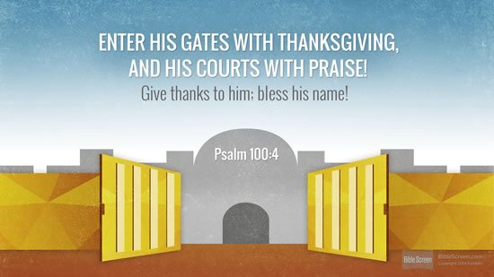

The Lord is good; his love is eternal, and his faithfulness lasts forever

Sing, Pray & Praise: As we gather, Father, seal us

As we gather, Father, seal us
In the love that knows no fear
Draw us, heal us, reconcile us,
May there be a place of refuge here.
Who share one living bread?
one Father’s love,
one Saviour’s grace,
one Spirit’s breath;
one holy communion.

No more outcasts, no more strangers
all dividing walls are down.
here is love that redefines us,
dignifies the least and lowest one.
Who share one living bread…

Source of joy, belonging, friendship,
form your family likeness here.
Father, Son and Holy Spirit,
that the world may know our God is near
Who share one living bread…

Prayer
We thank you, faithful Lord for all you have given us.
We marvel at the wonders of the world and watch in awe at the beauty of the flowers as they emerge and give us hope of a new life.
We thank you that you have given us the talents and skills that we need, and that, through your tenderness, compassion and love you have equipped us, taught us, and have guided us in the way to live.

But Lord, we know that sometimes we ignore your teachings.
We know that through our words and the way we act, we think only of ourselves and ignore the needs of our neighbours.
Forgive us Lord ……. And help us, Lord, to draw daily on your refreshing strength in order to cope with whatever our day holds. Amen.

RECEIVING

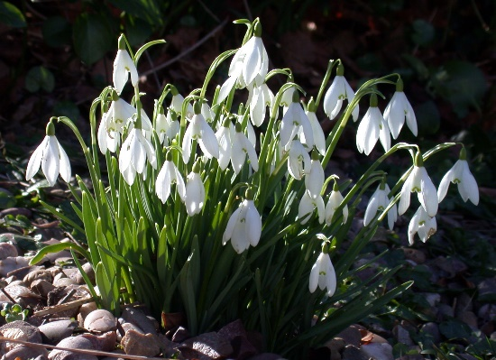
Reading: Genesis 17:1-10, 15-17

I am no gardener! I admit that I “do” things in the garden, but what I do is either because I am told to do it, or out of necessity to keep it tidy. But, even I, with my lack of green fingers, have marvelled, as I am sure many of you have done, how things have changed and are changing in the garden. There are new flashes of white, lumps of yellow and even small spots of red appearing.

But, as I have watched these changes, I have also been amazed how these frail plants have pushed their ways through thick, soddened earth to reach the sky and burst into flower. I have been astonished to see how a small frail looking snowdrop could emerge from the middle of a dense lump of clay. How does it happen, where does it get the strength to achieve it? I honestly do not know and, I am sure that, if I had not seen it with my own eyes, I would have said that it was impossible. But then sometimes, I feel that there are so many things around us that seem impossible.

When God first talked to him, I am sure that Abraham may have thought that God’s promise to He would make him and his descendants into a great nation, was impossible. How could that happen?
But, on the other hand, because he was a simple nomadic shepherd, someone who had no experience, no scriptures, no tradition, and no evidence why it should not happen, it was easy for him to believe. So, as the Bible records, he did believe. He left his home travelled south and he thought that he would be a father, even though he was 75 years old. He believed that it was not impossible that he would be the father of a great nation.

But, as we read earlier, 20 years later, when God again appeared to him and again promised that he would become the father of many nations, Abraham had doubts. He could not believe that it was possible. He simply laughed at the idea and said “how will a son be born for a man 100 years old, whose wife is 90 years. Surely God, that is impossible”. Have you felt like that? Have you been in a situation where what seemed possible, now seems impossible!

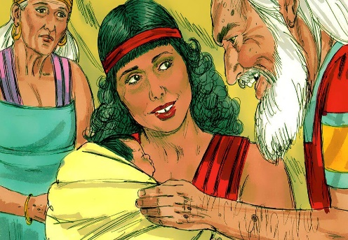
Has our enthusiasm, the uncluttered mind of youth disappeared? Has the clear faith that God can and will achieve everything disappeared, drowned out by our experiences, by what we see around us? How many of us have wondered how and whether the Covid pandemic will end? Would the impossible be achieved? Yet we know that the impossible was achieved. Abraham and Sarah did have a son, Abraham did become the father of all nations, just as God promised.

So perhaps the impossible can be achieved. Perhaps, as men and women using the skills and talents given to them, have found a vaccine to help stem the virus, so the impossible is being achieved today.

Today, we simply need to believe, to have faith that whatever happens, God is with us, caring for us and giving the strength to achieve the impossible.

As we read, when God told Abraham that he was going to become a father at the age of 99 years, he laughed. A laugh of disbelief. Later in chapter 21, we read that when Isaac was born, Sarah said “God has brought laughter for me: everyone who hears will laugh with me”. It was not the laughter of disbelief; it was the laughter of joy.
So, I pray that today and whenever we see and feel God around us, we too will laugh, the laughter of joy and happiness that He is with us. Amen

RESPONDING

Sing, Pray & Praise: Give me joy in my heart
Give me joy in my heart, keep me praising.
Give me joy in my heart, I pray.
Give me joy in my heart, keep me praising.
Keep me praising till the break of day.
Sing hosanna, sing hosanna, sing hosanna to the King of kings!
Sing hosanna, sing hosanna, sing hosanna to the King!

Give me peace in my heart, keep me resting.
Give me peace in my heart, I pray.
Give me peace in my heart, keep me resting.
Keep me resting till the break of day.
Sing hosanna…

Give me love in my heart, keep me serving.
Give me love in my heart, I pray.
Give me love in my heart, keep me serving.
Keep me serving till the break of day.
Sing hosanna…

Prayers of Intercession
As we seek to serve our Lord, and, with His love in our hearts,
let us reflect about our troubled world. Let us pray for our world and its people.

We pray for people who have little or nothing.
For those who feel trapped, feel locked in, and feel that everything is impossible, that there is no way out of their present situation.
Lord, give to them the feeling of your love, that sense of hope.

We pray for those who are hungry,
for parents who struggle to feed their children and themselves.
We pray, especially at this time for all those agencies and foodbanks who seek to bring comfort and relief to those who suffer. We pray that they will all have the resources to continue their work and pray for a time when their work will be completed.

Lord, open our eyes to those around us,
both those we know and to strangers.
We pray for those we see every day, and those who we simply hear on the end of a phone or through the internet. We pray for those who are far away and with whom we only have occasional contact.

And we especially pray for our families, our friends and those in our churches. ……. In a moment of silence, we pray for people or places who we know personally and who today need the love and care of the Holy Spirit.
Lord help us to see and understand the burdens they are all carrying. Give us the strength and wisdom to care, and to pass onto them Your Love. Amen
Lord’s prayer…. Our Father, who art in Heaven…….

Blessing

As we end our worship, Lord, give us joy in our hearts,

give us peace in our hearts and love in our hearts.

We pray that You will keep us praising,

keep us resting and keep us serving to the break of day.

May the grace of our Lord Jesus Christ keep you and those you love,
today and in the week ahead. Amen.
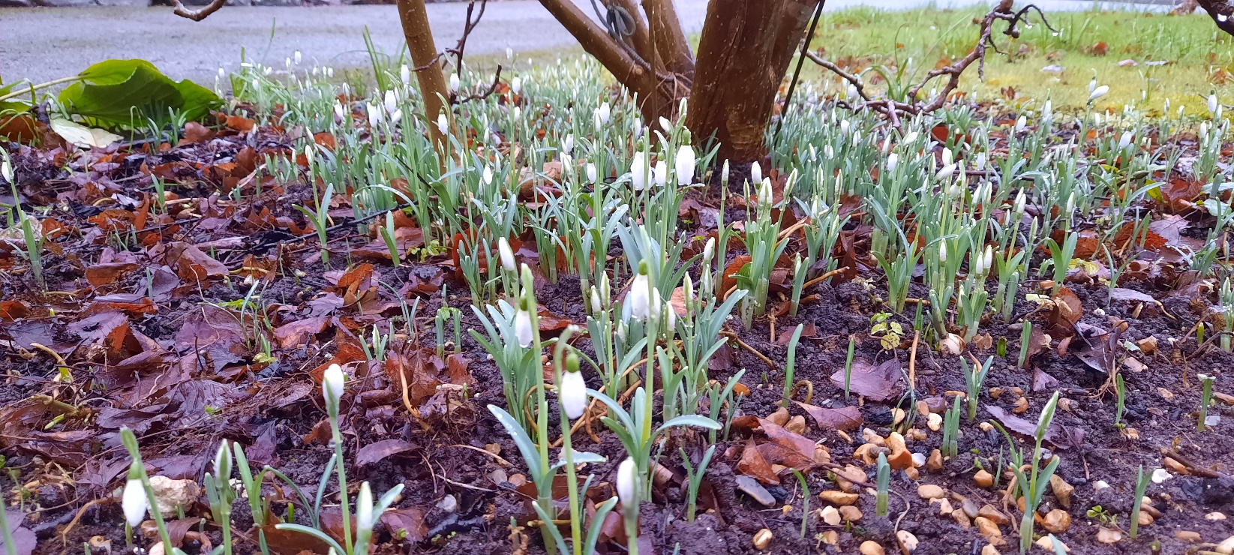
Snowdrops of Hope, © Dan Balsdon 2021

Acknowledgements
Song words reproduced under CCLI Licence| original material, formatting + editing by Rev Dan Balsdon
Bible texts from NRSV unless otherwise stated, www.biblegateway.com
Image reproduced under Creative Commons Licence unless otherwise stated

Worship for Sunday 7th February prepared by Lynne James.
I watch the Sunrise, by John Glynn © Kevin Mayhew, StF469
Will you come and follow me, by John Bell & Graham Maule, StF673
Worship for 14th February prepared by Hazel Denman
Prayer from the Methodist Prayer Handbook 2020-1, p53, by a year 4 pupil at The Vine Inter-Church primary School, Cambourne
When the bonds of love are breaking by Herman G. Stuempfle, StF656, v1 & 2
Test from New International Version 2011.
When the bonds of love are breaking by Herman G. Stuempfle, StF656, v1 & 2
Worship for 21st February prepared by Shelagh Morgan
Lead us Heavenly Father, Lead us by James Edmeston, StF238
O Christ the Healer by Fred Pratt Green, StF653
Worship for 28th Feb prepared by Malcolm Lindo
As we gather by Graham Kendrick, © 2004 Make Way Music, StF570

