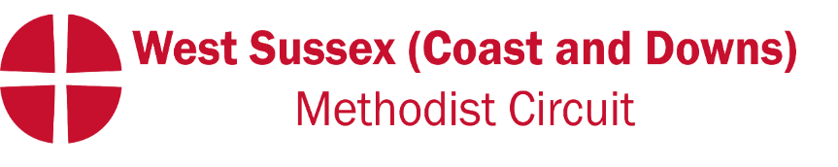
Please send your news for December, January & February to:
office@westsussexcoastanddownscircuit.co.uk

September 2023
Quarterly Circuit Newsletter, sharing news and forthcoming events.
WELCOME
A warm welcome to the Revd Tongayi Matamba and his wife Rudo who join us from Zimbabwe. He will be working particularly with Bognor Regis, Felpham, Selsey and Westergate and we look forward to getting to know him in the weeks ahead. The first opportunity will be at the Welcome Service but please read the introduction note from Tongayi on the next page.
LAST QUARTER
Some churches held special events to celebrate the Kings coronation. Littlehampton United Church had an ‘African Inspired Art Exhibition’. Steyning MC provided refreshments at the Open Gardens. We said farewell to the Revd Dan Balsdon and family who moved to the Dorking and Horsham Circuit, and goodbye to two well loved and respected Local Preachers in Ann Foster and Joyce Stroud who are now at peace and with Christ.
NEW WEBSITE
Christ Church Chichester have a new website: christchurchchichester.org.uk. They also have two new email addresses : info@christchurchchichester.org.uk which will go to a Senior Elder and minister@christchurchchichester.org.uk to contact the Revd Helen Higgin-Botham.
LEADING YOUR CHURCH INTO GROWTH
The ‘Leading your Church into Growth (LyCiG)’ course has been running in the circuit with through May and June. The course was another opportunity to take a step back and reflect upon where God is leading us in our mission and ministry. It has been encouraging to hear initial feedback and the action some churches are planning to take and/or have already taken in response to the course. Please pray that these conversations and actions will continue to develop as we seek to serve Christ in our contexts.
DATES FOR YOUR DIARY
Saturday 12th August at 12.30pm Circuit BBQ at Rustington – please bring desserts to share (no nuts thank you),
Tuesday 5th September at 7pm. Our Circuit Welcome Service for the Revd. Tongayi Matamba and his wife Rudo at Westergate Methodist Church.
Wednesday 13th September 7.30pm. Circuit meeting at Rustington.
Wednesday 27th September 7.00pm An Eco Church talk at Offington Park Methodist Church by Karen Park from Horsham. Karen will share with us how to get started on the Eco Church journey or progress further, and is a real expert in this area. Ideally, we would like at least one representative from each church so they can feedback to their fellowship.
Saturday 14th October. PLEASE SAVE THE DATE! Equality, Diversity & Inclusion (EDI) workshop at Offington Park Methodist Church (half day). Details and invitations to follow but all Ministers, Local preachers, Worship Leaders, Circuit Stewards, Church Stewards, Lay workers will need to either attend on 14th October or complete the training on-line by 31st December. Others are warmly invited to attend if they wish.
An introduction to The Revd Tongayi Matamba
Friends, I greet you in the name of our Lord and Saviour Jesus Christ.
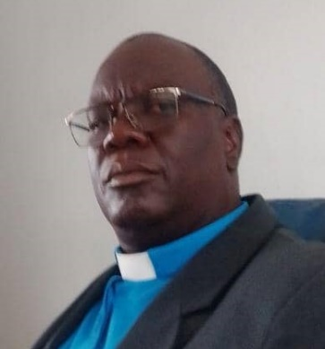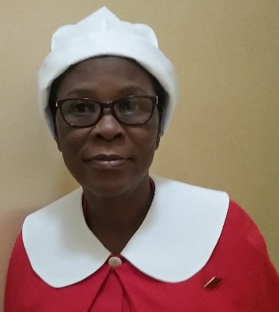
My name is Tongayi Joseph Matamba a minister from the Methodist church in Zimbabwe coming here to serve as a Methodist of Other Church or Connexion (MOCC). I am married to Rudo and we are blessed with two children Shingayi and Tapiwanashe Ruth. Shingayi is 29 years old and Tapiwanashe is 23 years old.
I was born and bred as Methodist and my parents were active Methodist members, especially my mother. After completing my preachers’ course, I started the process of itinerant ministry in 1992 and was accepted by Conference to start training in 1993 for a diploma in theology and religious studies. The training for ministry took four years and I was posted to my first station in 1995. Since then, I have travelled around the country doing ministry in different circuits.
I have worked in rural, urban and mining areas. The rural areas were agro-based and some with a poor rainfall pattern.
I have heard the opportunity to work as a circuit minister under a superintendent. I also have worked as a Synod Secretary for Marondera district and Evangelism Coordinator for Kadoma district. During the course of my ministry I have also worked with ecumenical bodies like the Zimbabwe Council of Churches. Working with other churches has helped me understand other denominations and how they operate and their theology as well.
My wife and I are very delighted to join the Methodist Church in Britain because it gives us the chance to understand Methodism in a different context. Being appointed to this circuit will help us learn the dynamics of ministry in a culturally different environment.
We look forward to working together both as one family and as team members.

