**Please send your news for March, April & May to:**

**office@westsussexcoastanddownscircuit.co.uk**

December 2023

**Quarterly Circuit Newsletter, sharing news and forthcoming events.**

**LONG SERVICE AWARD**

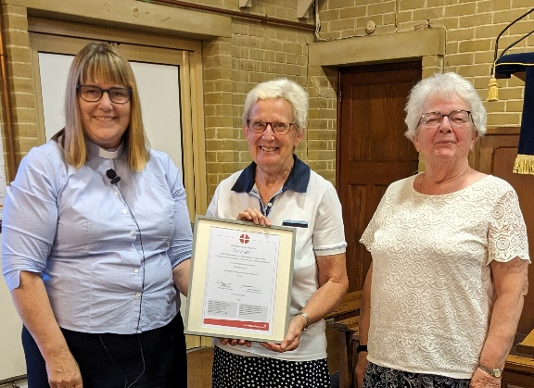At the recent circuit meeting on the 4th of September, we were delighted to present a certificate to Shelagh Morgan in recognition of 25 years’ service as a local preacher. Shelagh is pictured in the centre having received her award from The Local preachers Secretary Wendy Corney (left) and our superintendent Revd. Rosemarie Clarke (right).

**WORLD MISSION MONEY**

Anita Hayward has reported that from the information she has received the Circuit gave at least £2386.09 to the Methodist World Mission fund in the 2022/23 financial year. Many thanks to everybody for their generosity.

**CIRCUIT BBQ**

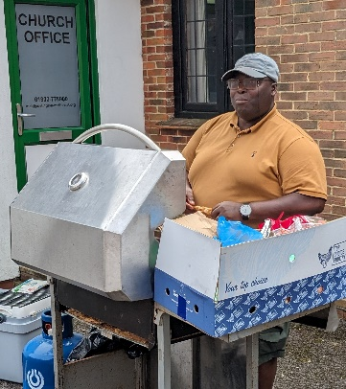Despite the inclement weather the BBQ went ahead mainly in the church hall at Rustington MC on the 12th of August. The Revd. Dr Frank Okai-Sam is pictured doing a marvellous job cooking all the food. Our appreciation goes out to The One World-One Family Group and those at Rustington for helping to organise this.

**WELCOME SERVICE**

Summer eventually arrived on the 5th of September when a very warm welcome service was held for the Revd. Tongayi Matamba and his wife Rudo at Westergate MC. Tongayi is the new minister currently serving Bognor Regis, Felpham, Selsey and Westergate Methodist churches. He arrived in the UK from Zimbabwe on Sunday 27th of August and the following week was leading worship at Selsey! Many thanks to the members of Westergate for hosting this event and providing some scrumptious homemade cakes for afterwards.

**DATES FOR YOUR DIARY:**

**Monday 12th December at St Symphorian’s Church, Durrington 7.30pm Turning Tides Carol Service.** Several churches within the circuit support this local homeless charity. The event is hosted by the Board of Trustees and will feature the Durrington Infant and Junior School Choir. There will be refreshments and a tombola.

**Sunday 24th December at Goring MC 3pm Live Nativity.** A procession through the local streets of Goring with a live nativity performance. The Salvation Army Band will be in attendance for carol singing.

**OFFINGTON PARK COMMUNITY OUTREACH PROJECT (COP)**

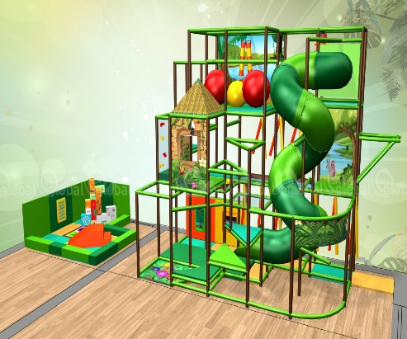 Our exciting COP project continues to advance at a rate of knots.

 We recently welcomed back our regular users of the hall which now looks resplendent in pure brilliant white. It is now a light and airy much larger space due to the removal of the partition doors.

Work continues to the hall with the recent fitting of remote-control white blinds to the four upper windows and on the west and east aspects of the main hall. The next major change in this room will be the floor.

We have carried out some floorboard repairs and will be laying a new ply floor which will then by covered with a Gerflor luxury vinyl. New LED lights will replace the existing sodium lights and new radiator covers will be fitted.

We have already fitted new sockets with USB points along the eastern wall.

We will be signing off the final design for the soft play frames during October and we expect to move into the manufacturing stage by the end of November. A picture of the (almost) final design is shown.

Clearly, the soft play is designed to attract the children, but the whole concept must appeal equally to the adults who bring them.

Therefore, a very necessary part of our project is new toilets and quality catering facilities, for the more modern, attractive and appealing the whole café area is, the longer people will want to stay and purchase items.

A secondary ‘win’ is the more likely it will be that they view the soft play as a fantastic place for packaged parties at an all-inclusive price.

Having on-site catering and toilet facilities creates a one-stop shop and enhances the overall security of the area, which is an important safeguarding consideration.

Soft play, party bookings and café sales are expected to contribute roughly one third each to the overall income stream, so we are carefully considering how we make the kitchen a better space.

We will need to cater for soft play users as well as our existing mission initiatives. We know that we can install new WCs in the Main Hall where the existing cupboard is.

The new WCs, which will improve security and access to toilets for existing as well as new users, will take up this cupboard space and part of the toy cupboard which is accessed currently from the vestibule of the Alan Fletcher Hall.

All of this has been possible thanks to the generosity of both the Circuit and the District. We are immensely grateful to the Circuit Meeting for agreeing to match the amount of money we ourselves have put into this project. In turn, this has enabled (or encouraged!) the SE District to also match that funding, meaning that, together with some generous donations from our members,  we already have over 60% of the funds needed to complete ALL the proposed work. We are really encouraged by the support of the Methodist Church, and we understand that with such generous pledges already made, securing funding from other funders sympathetic to mission causes becomes slightly easier. We hope and pray that this is so and that they will be as generous so that we can advance the Kingdom and make Offington Park a ‘go-to’ community space.

We already have a number of ideas about how we might share the good news of Jesus in this setting, the role of the manager of this space will be key in taking this forward.