Please send your news for March, April & May to:
office@westsussexcoastanddownscircuit.co.uk

March 24
Quarterly Circuit Newsletter, sharing news and forthcoming events.
DURRINGTON COMMUNITY CENTRE CHURCH 39TH ANNIVERSARY
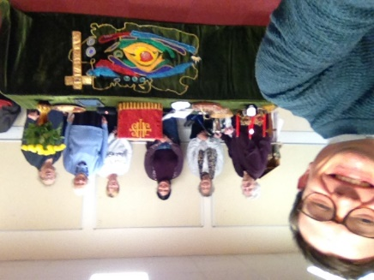
On Advent Sunday, 30th November, we celebrated our 39th Church Anniversary, with our Minister Revd Steven Donnison leading our service where we shared together in a Holy Communion Service. We lit the first of the candles on Advent Ring and also displayed our Nativity Set.
We chose hymns and Steven accompanied us on guitar. During the service and prayers we took time to reflect on the past, remembering Ministers, members, associates and friends of our church throughout the years and prayed for the future of the Community Centre Church, as a class of Goring Methodist Church. Linda Leaney
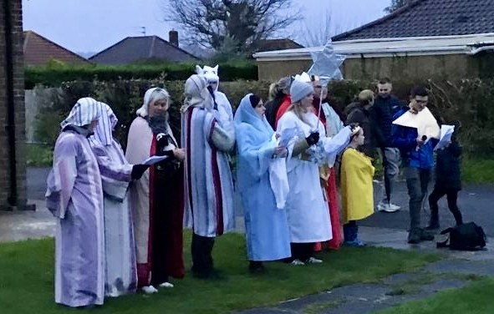
LIVE NATIVITY AT GORING
On Christmas Eve a crowd gathered on the church lawn before setting off on a parade of the local streets whilst telling the nativity story and singing carols accompanied by the Salvation Army band. We returned to the warmth of the church to complete the story and singing and then enjoyed festive refreshments afterwards.

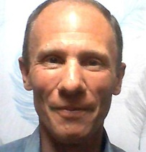
TIM COOPER
Since January 2022 Selsey Methodist Church has been blessed with enjoying working alongside Tim Cooper, our Lay Pastor. An inspired idea by Rev Dawn Carn supported by Revd Ian Suttie, Superintendent at the time, led to a Circuit appointment of 2 years for Tim to share his skills, ideas, enthusiasm and wife with Selsey MC.
From day 1 Tim presented as an energetic friend, coming into a situation where the church Leadership Team had been working together for quite a few years. His smiley approach, first class listening skills, pretty good voice & a mass of ideas for us to join with him in working through.
Tim’s skill in engaging with the huge Junior Church at Selsey….well, usually 2 maybe 4 children, became apparent. But far more, his easy adaptability to embrace the needs of those of us over 25, indeed church members and adherents of every age, has shone through constantly and consistently…..we have all benefitted greatly from sharing Tim & Caroline. Caroline has made herself a great supporter of much of what we do and stand for.
When Tim has to move on after Easter, he leaves SMC in a really good place looking forward. Our work with Selsey Community Forum has grown, as has liaison with the other 3 churches in Selsey. We will always be grateful to the Circuit and Tim for his wonderfully supportive work with us all at Selsey. Thank you. You will be missed.
DATE FOR YOUR DIARY:
Saturday 2nd March at GoringMC at 10.30am. Action for Children Coffee Morning. There will be cake and craft stall plus jams and marmalades for sale.
Sunday 17th March at Offington Park MC 2.30pm. A Circuit Peace Event when there will be prayer stations for different areas of conflict around the world followed by refreshments and then a Circuit Peace Service at 3.30pm.
Saturday 4th- Monday 6th May at Steyning MC. Flower Festival.
Saturday 11th May at Goring MC at 10.30am. Christian Aid Coffee Morning. Another worthwhile cause where tea and coffee need to be consumed. More cakes, jams and marmalades for sale plus a craft stall.
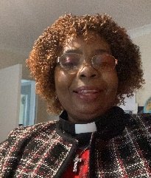
A WARM WELCOME TO DEBRA
The Reverend Dr Debra Chidakwa-Akue will be working in the circuit (mainly at Offington Park Methodist Church with Revd Dawn Carn) for 15 hours a week until the end of August; Debra also serves as a part -time chaplain in the West Sussex Hospitals. Debra herself writes:
Greetings! I like to be called Debra. I am married to Jonas Akue, and we have six grown up children and six grandchildren (one on the way). I am a spirit-filled believer in the salvation of Jesus Christ who pursues an ongoing relationship with God, with several years of experience in church ministry in the UK and the USA. I am capable and experienced in staff and volunteer management, and passionate about church outreach as well as mission ministry and willing to embrace new ways of how we can grow the church and spread the Good News. I love to Preach the Gospel of Jesus Christ through weekly worship and Bible study, and equip and motivate the congregation to reach out with the Good News to all in the community, especially those who are sick, homebound, or in crisis. Debra
IAN COUCHMAN’S GRADUATION
On a cold winters day at just past 7am, Pam (my wife) and I found ourselves heading to Durham University. It was something special to be in the Grand Hall with around 300 other individuals many who were in clerical clothing.
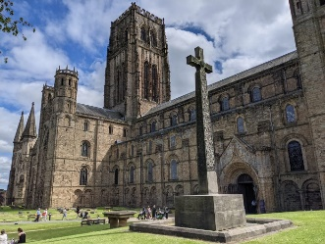
We processed from the Grand Hall to the Cathedral for the graduation ceremony. As our names were called and we stepped forward to shake the Vice Chancellors hand, it became real that the hard work had paid off.
It was the culmination of five years work that sometimes seemed to be a daunting task.
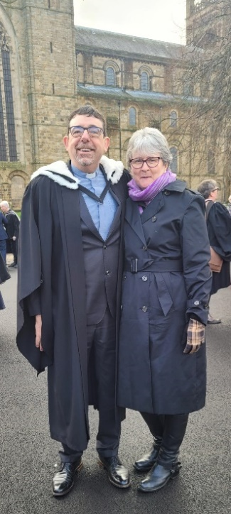
For my dissertation I chose to write about how the church engages in a meaningful way or not with individuals who have an intellectual disability with reference to Hebrews 13: 1-2. ‘Keep on loving each other as brothers and sisters. Don’t forget to show hospitality to strangers, for some who have done this have entertained angels without realising it! (New Living Translation)
One of the main arguments of my dissertation concerned how the Church has unknowingly entertained angels without knowing it when engaging with individuals who have an intellectual disability. I explored how the church has ignored in so many ways the voice of disabled individuals within its fellowships, and how we hear the voices of individuals who are neuro diverse and yet sometimes ignore the words that are spoken.
I argued that as worshiping communities we have the power to include or exclude the opinions of individuals who have an intellectual disability. If we exclude those individuals we diminish God’s presence within our fellowships.
I thank the Methodist Church for gifting me the opportunity to train at Queen’s in Birmingham for a bachelor’s degree in Theology, Ministry and Mission. It has been a privilege, a challenge and many other emotions besides.

