**Please send your news for Sept, Oct & Nov to:**

**office@westsussexcoastanddownscircuit.co.uk**

**June 24**

**Quarterly Circuit Newsletter, sharing news and forthcoming events.**

**YOUTH WEEKEND AWAY ON A BOAT - CHRISTIAN YOUTH ENTERPRISES, CHICHESTER HARBOUR**

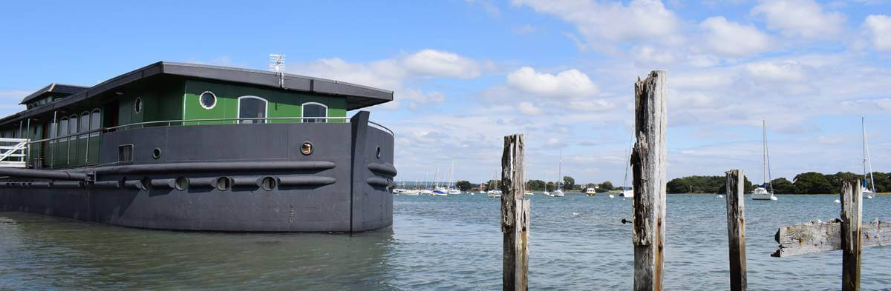The circuit youth weekend away was a fantastic mix of meaningful activities and pure fun and chaos. On Friday, we held worship and had a quiz night which included a round on transformers, Harry Potter, darts and Charlotte’s favourite… maths! After a late night which included an unofficial 1am Bible study we got up at 6am the following morning to see a non-existent sunrise! However, the scenery was extremely peaceful and the sky was beautiful, even without a sunrise. The boat was lovely and clean with excellent staff and outstanding food. On Saturday, we went on a gorgeous walk through the surrounding countryside and it was so beautiful. We were walking on a raised path in the middle of a lake and the views were stunning, it was so lovely to be outside connecting with nature. After we returned from the walk, we sat down to play a very vicious game of snap (Taco, Cat, Goat, Cheese, Pizza – in case you were interested!) with the leaders and other young people. This was most certainly one of the best highlights from the trip as we all had fun together, laughing continuously throughout the entire game, and it gave us an opportunity to bond more with the other youth group. Although, this did leave Charlotte with two bruised wrists! A lot of effort and hard work was put in to make this trip educational yet so fun with activities including a Bible quiz, 2 engineering challenges and a discussion on what faith means to us. All this was topped off in the evening with a movie night and worship. Sunday was our last day and after another late night due to a self-organised Bible study, we woke up again to watch the sunrise which was more spectacular than the previous day.

Overall, we all had an amazing time, from the coach journey there to packing up our bags on the last day, we were always laughing and enjoying our time together. We all connected with new people, forming friendships which we hope to grow stronger this year.

We would like to say a final thank you to the amazing staff, all of the adult leaders who were so lovely and kind, to Dawn and our own youth leaders: Richelle and Lee who all made the experience a wonderful memory which will last forever. *Isabella, Charlotte, Milly*

**DATES FOR YOUR DIARY:**

**19th May – 13th June** 11—4 Tuesday to Sunday - Methodist Modern Art Collection will be at

Emmanuel Church, Upperton Road, Eastbourne BN21 1LQ.

**Sunday 9th June at Goring MC 3pm –** Testimony Service for the Revd Steven Donnison. Please come to

support Steven before his ordination in Yorkshire.

**Saturday 6th July at Goring MC Summer Fair**

**Sunday 14th July at Trinity Storrington 3pm.** Circuit Farewell Service to Revd Dr Frank Okai-Sam.

**Saturday 14th September 7.30pm.** Cornerstone Methodist Church, London Rd, Horsham

Philippa Hanna in concert. 07869802024 for tickets £18

**TRINITY SUNSHINE CHOIR**

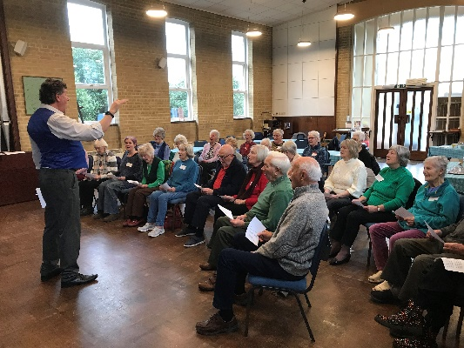A dementia friendly choir started in August 2023 by Trinity Methodist Church, Storrington has steadily grown in numbers attending, with 25 or more participating in the last four sessions. Launched in furtherance of Trinity’s mission to identify need and make a difference in the community the choir is led by cognitive stimulation therapist, Ric Gray. “We believe that singing is good for our health and well-being”, says Ric. “We are a very welcoming social group that meets monthly to sing together. We don’t take ourselves too seriously and we sing popular songs from across the years. There are no auditions or music scores and our aim is to provide an encouraging, fun-filled session to which all are invited.”

“Everybody is extremely friendly and welcoming,” says befriender Jill Kennedy. “I have never been in a choir before, but I can’t believe how great I feel at the end of the morning. You meet new friends, exchange experiences, help each other and leave with a huge smile on your face.”

“While the majority of us are subject to some memory loss”, says octogenarian and local preacher Brian Kelley, “it’s good to know that those living with dementia can enjoy popular songs of the 20th century. Glancing round during the singing one can see that every face is absorbed and every larynx in full flow.

The choir usually meets on the last Wednesday of the month for 90 minutes, starting with coffee and a chat at 1030. Anyone interested can contact Robert Gamble at robertgamblerc@gmail.com or 07958 232874.

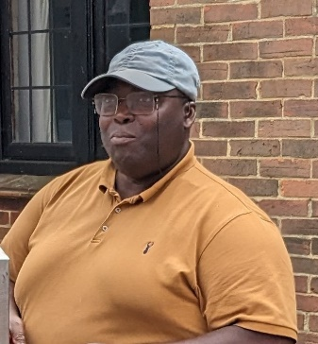**FAREWELL TO REVD DR FRANK AND MRS PATIENCE OKAI-SAM**

The outbreak of Covid in March 2020 with the resulting restrictions meant that Frank had to switch quickly to a completely different style of ministry whilst still settling into his new role. When we did return to face-to-face worship and activities, Frank faced the challenges of smaller congregations with some reluctance to return to ‘normal’. This summer we will say goodbye to Frank and Patience. A Circuit Farewell Service will be held on Sunday 14 July, 1500 at Trinity Methodist Church, Storrington and we hope many of you will be able to attend. Frank and Patience moved here in September 2019 from the Doncaster Circuit and Frank has been Minister at Trinity and Southwick since then.

We ask for God’s blessings on Frank and Patience as they move to the Herts and Essex Border Ecumenical Area (HAEBEA) Circuit where Frank will be Superintendent Minister and hope that they will soon feel at home there.

**TESTIMONY SERVICE - REVD STEVEN DONNISON MA**

After a period of two years as a probationer presbyter in the circuit Steven has been adjudged to have achieved the competencies necessary for an ordained minister in the Methodist Church, and looks forward to his reception into full connexion and ordination in Yorkshire at the end of June. These things always happen as part of the annual Methodist Conference and sadly we will not all be able to be there to shout enthusiastically ‘they are worthy’ at the appropriate moment in proceedings. It has long been the practice for ordinands to have the opportunity to share their testimony locally. So it is that we have the privilege of hearing Steven’s testimony on the afternoon of 9th June at Going Methodist Church, and I hope as many of you as possible will make it your priority to be there to support Steven on that occasion.

*Rosemarie*