**Please send your news for December, January & February to:**

**office@westsussexcoastanddownscircuit.co.uk**

**Quarterly Circuit Newsletter, sharing news and forthcoming events…** **September 24**

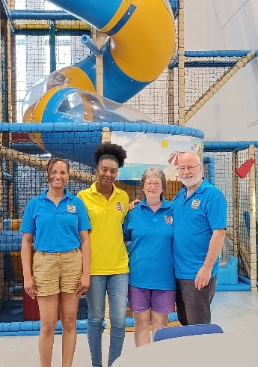**WELCOME TO TESSA LITTLE THE LIGHTHOUSE SOFT PLAY MANAGER**

I wear a few important hats....mum, wife, daughter, big sister to my four siblings, friend and most recently acquired, manager at The Lighthouse.  After 18 years in hospitality starting out as a receptionist and working my way up to senior management, life began to feel very challenging while juggling everything. I began to feel like I was on a very stressful treadmill. I knew something had to change so I started looking for a job in Worthing so that I could get out of the commute to Brighton as well as leave hotels.  My home church is Elim Worthing and I chatted with my minister, Andrew Fadoju, about wanting to be able to get the right work-life balance and to be able to experience some of that abundant living God talks about.  He encouraged me to not

**(Tessa is in the yellow polo shirt)**

make a hasty decision and said he would help me pray about the situation.  The very next day while on the train to work he text me the job advert that he had received that morning. God was setting things up even when I felt stuck.

From my first week at OPMC I felt like part of the church family and everyone has been welcoming and supportive. Its amazing because Dawn and I share the same vision for The Lighthouse. We believe God's vision for the soft play is more than just a place for children to come and have fun.  We believe that for the parents and carers coming through the doors, we should be able to support, encourage and if necessary, signpost them to organisations who can help them further.  We both believe that evangelism is about the love and care you show to people and that sometimes, even without quoting a bible verse, what you do shows people God's love and light.

The team of volunteers are amazing. Everyone gets stuck in regardless of what needs doing. Many of the volunteers at the moment are members of the implementation team who worked with Dawn to bring the Lighthouse from being a vision to a reality. We are working towards building a bigger team so the work load is spread more evenly. The feedback from the public so far has been amazing and encouraging and we are just getting started. We are doing our bit as God works out his big picture plan through us.

Tessa Little, Church Community Development Manager, Offington Park Methodist Church

**NEW RESPONSIBILITIES**

|  |  |
| --- | --- |
|  |  |
| **The Revd Ian Couchman**  As from the 1st of September Ian will take pastoral charge of the Methodist Church at Southwick as well as those at Lancing and Shoreham. | **The Revd Steven Donnison**  As from the 1st of September Steven will take pastoral charge of the Methodist Churches at Storrington, Goring (including Goring Methodist Church at Durrington) and Steyning. |

**DATES FOR YOUR DIARY:**

**Saturday 7th September: 10:30am -12:00pm**. Coffee Morning - Tea, Coffee and homemade treats available. **Proceeds to go to the Circuit youth project including 3 Generate.**

**Saturday 5th & Sunday 6th October at Southwick MC** at 7.30pm. Worship Concert. Shout to The Lord live event Tickets £14 Box office 07834 073640

**Saturday 19th October at Goring MC 10.30am.** Action for Children Coffee Morning with teas and coffee, cakes, jams and preserves, sausage baps plus craft stall.

**Saturday 16th November at Steyning MC.** Christmas Bazaar with the Sing Out sisters, a ladies’ choir, gift stall, cakes stall, tombola, charity stalls and gifts from turned wood.

**STEVEN’S TESTIMONY SERVICE AND ORDINATION**

On Sunday 9th June the circuit gathered at Goring Methodist Church to worship together and hear Steven Donnison’s testimony. The service began with an introit, which was beautifully sung by members of Steyning MC and continued with contributions from members across the circuit in the form of Scripture readings and prayers. 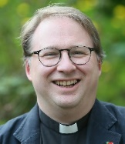Revd Dr David Hinchliffe the District Chair was the preacher and urged Steven to always remember his call from God. The church was packed with friends from across the circuit and beyond. There were also some delicious refreshments afterwards and a nice opportunity to catch up with friends from across the circuit.

On the morning of 30th June Steven was received into full connexion with the Methodist Conference and later that day travelled to Brighouse Central Methodist Church where he was ordained. He was supported by family and friends including a contingent from Goring Methodist Church. Meanwhile about 30 people gathered at Goring Methodist Church and watched the ordination service via a live stream, followed by tea and cakes.